Contents

**1.1 ON-PAGE SEO AUDIT** 2

**TITLE TAGS ISSUE** 2

**META DESCIPTION ISSUE** 4

**H1 TAG ISSUE** 6

**H2 TAG ISSUE** 8

**URL STRUCTURE ISSUE** 9

**CONTENT OPTIMZATION SUGGESTION** 11

**IMAGE OPTIMZATION ISSUES AND SUGGESTION** 12

**SCHEMA MARKUP ISSUES** 13

**1.2 TECHNICAL SEO AUDIT** 16

**SITE SPEED AND PERFORMANCE** 16

**MOBILE-FRIENDLINESS** 18

**CANONICALIZATION & DUPLICATE CONTENT** 19

**INDEXABILITY & CRAWLABILITY** 20

**2.1 KEYWORD RESEARCH & STRATEGY** 24

**HOME PAGE KEYWORDS** 24

**KEYWORDS FOR CLOTHING CATEGORY** 24

**2.2 CATEGORY PAGE KEYWORDS** 25

**3.1 Competitor Analysis & SEO Strategy** 26

**Keywords Competitor Analysis** 26

**Recommendations:** 26

**Competitor Backlinks Analysis** 27

**Recommendations:** 27

**3.2 SEO STRATEGY** 28

**Crawlability and Indexing Strategy** 28

**Content optimization and internal linking** 28

**Long-Term SEO and Authority Building** 29

**Ongoing Monitoring and Continuous Improvement** 29

# 

# **1.1 ON-PAGE SEO AUDIT**

## **TITLE TAGS ISSUE**

* 52 pages have duplicate Tiitle tag

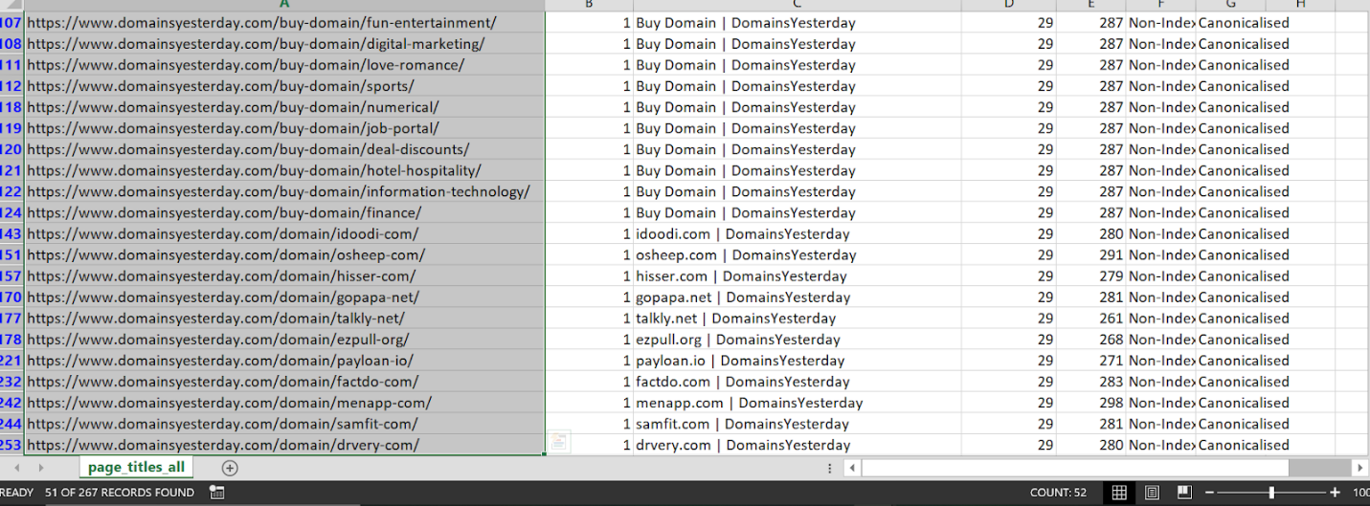

* Two page dont have title tag

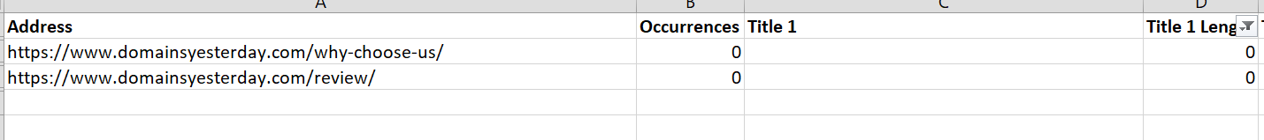

* The image below serves as proof that many title tags contain domain URLs within them, which is not ideal for SEO optimization.

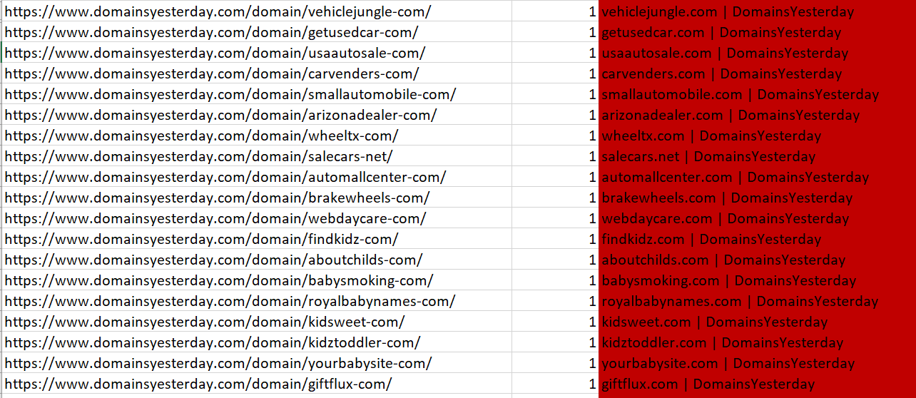

## **META DESCIPTION ISSUE**

* This meta description is placed on 48 pages  have duplicate meta description and 2 pages have above 155 characters of meta description

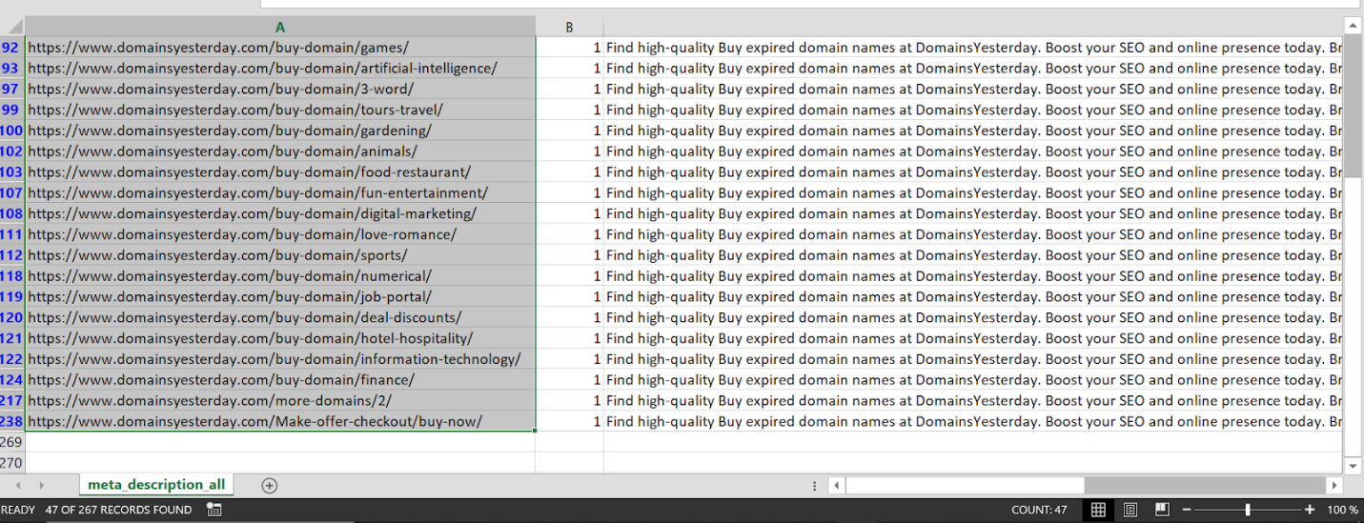

* 217 pages dont have meta description

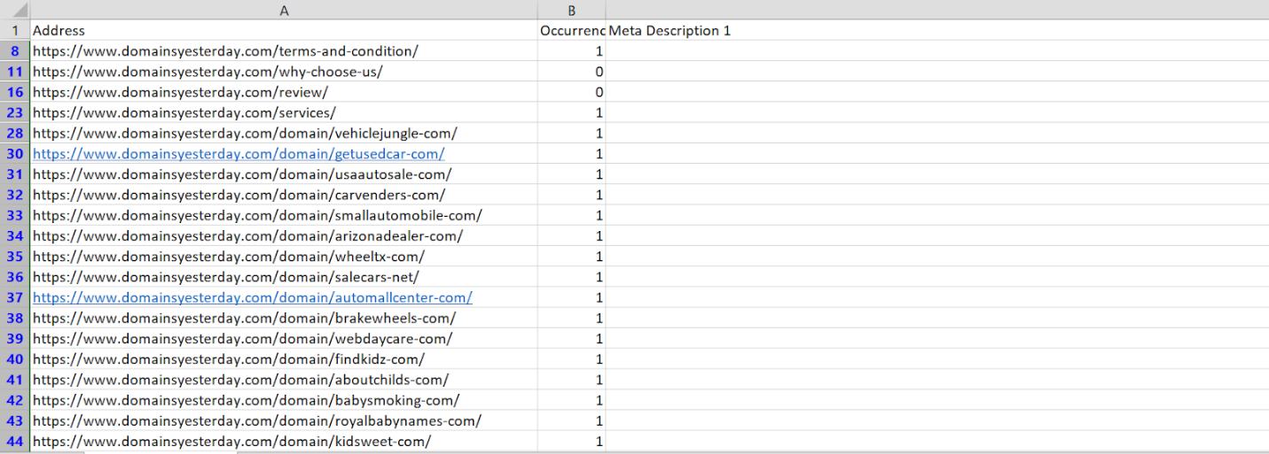

## **H1 TAG ISSUE**

* The H1 tag does not describe the main topic or purpose of the page. There are 212 pages where the H1 tag of the URL of the page is showing up, does not accurately describe what the homepage is about. And many title tag is similar to h1 tag which should be not because the title tag and h1 use for different purposes title tag increases ctr and h1 increase engagement rate that why title and h1 tag should be unique

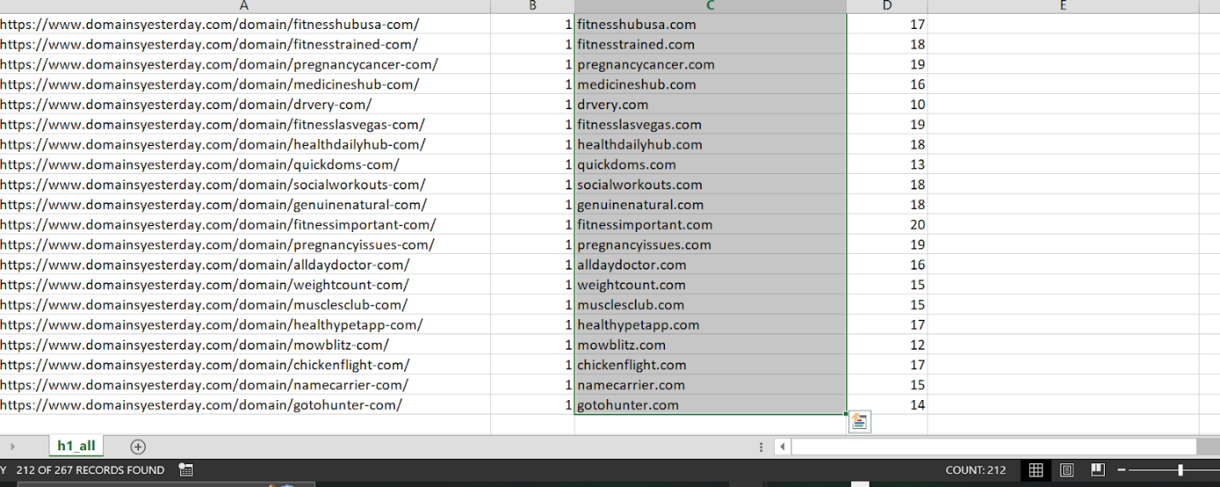

* Some H1 are repeating

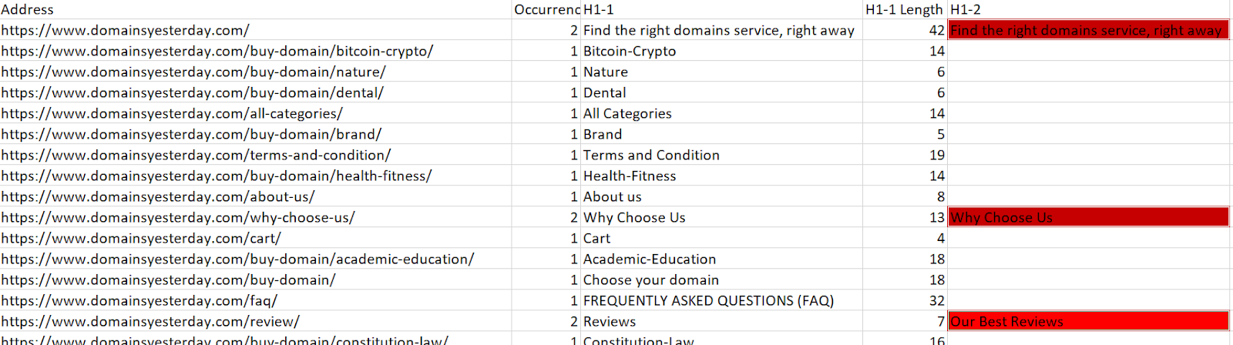

## **H2 TAG ISSUE**

* There are multiple H2 tags present on the pages, which should be limited to one for proper heading hierarchy, while the remaining should be converted to H3 tags. Additionally, some pages are missing H2 tags

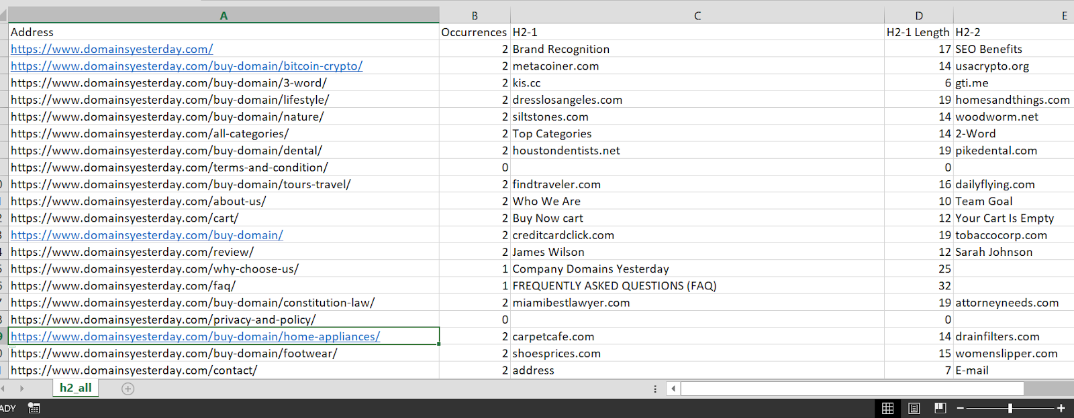

## **URL STRUCTURE ISSUE**

* The URL structure for the domain page should follow this format: **"domain.com/category/gti-me"** instead of the current structure.
* Categorizing domains under a relevant category helps search engines understand the page's content.
* It also Improves User experience a clear and meaningful URL structure makes it easier for users to navigate and understand the website.

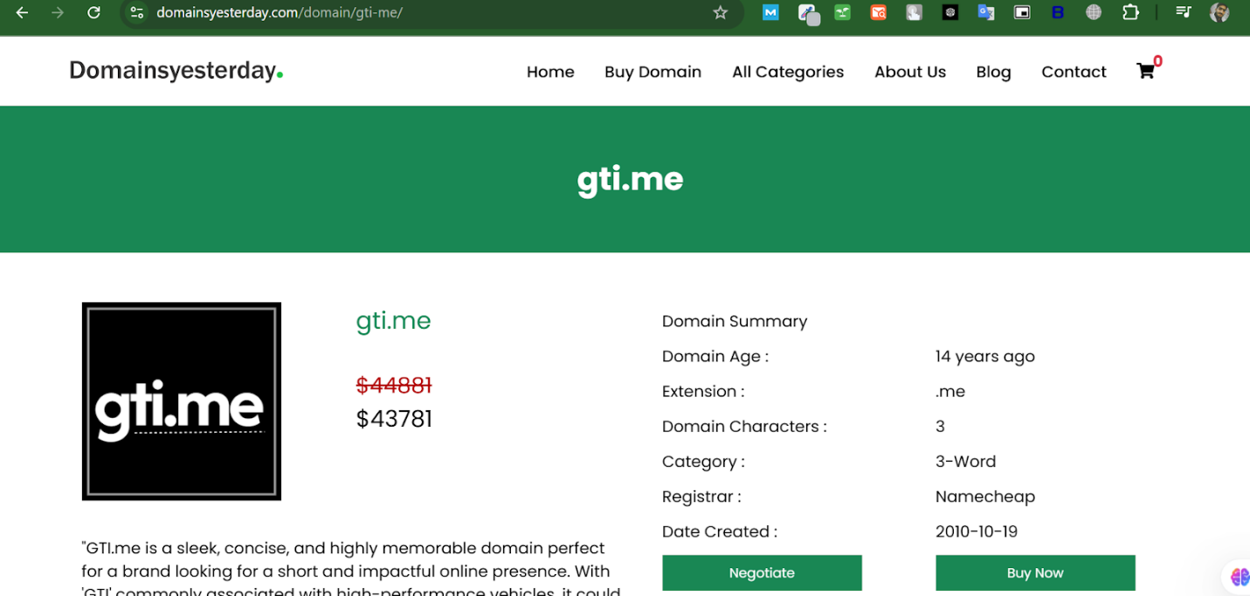

* The category page URL should be [**domainyesterday.com/category/home-appliances**](http://domainyesterday.com/category/home-appliances) instead of [**domainyesterday.com/buy-domain/home-appliances**](http://domainyesterday.com/buy-domain/home-appliances). Because It gives a proper structure and improve User experience

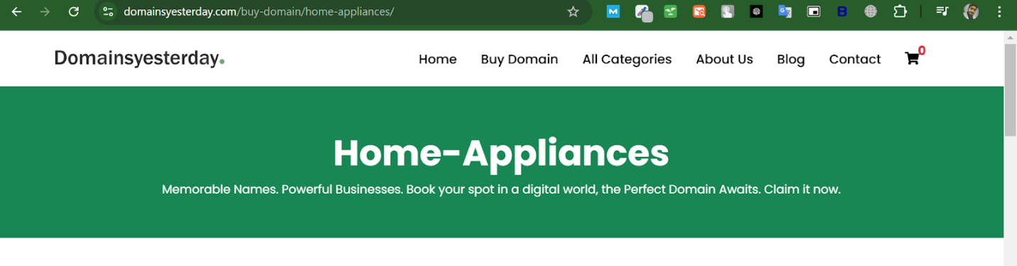

## **CONTENT OPTIMZATION SUGGESTION**

Each category page should be optimized using relevant **commercial keywords**, such as "best beauty skincare domain**"** and other commercial keyword which have low KD

Currently, there is no content on these category pages. Adding content will:

Help search engines understand the page’s purpose.

Improve keyword optimization and rankings.

To enhance search engine visibility and user engagement, the following strategies should be applied:

Incorporate high-quality, keyword-rich content within category pages.

Implement internal linking to which build site authority.Improve website navigation,Increase Engagment rate

## **IMAGE OPTIMZATION ISSUES AND SUGGESTION**

* The report indicates that **23 images are missing alt text**, which should be added to improve SEO, Alt text helps search engines understand image content which improves rankings, It improve User experience also and properly labeled images can be indexed faster

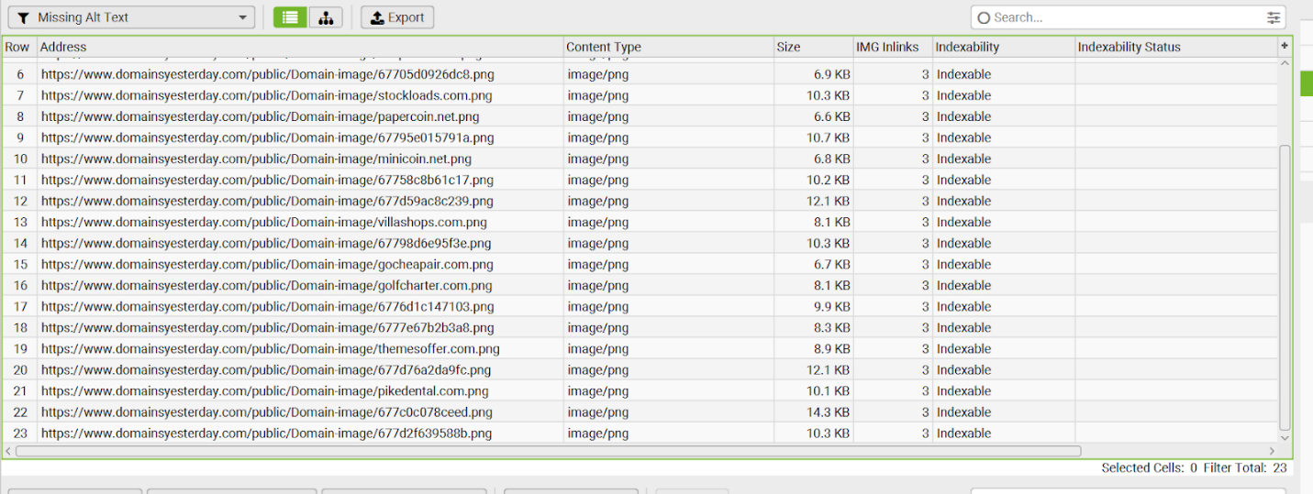

* All images should be In webp format, WebP images are significantly smaller than PNGs without losing quality, improving page load speed.

## **SCHEMA MARKUP ISSUES**

* There is no **Organization Schema** implemented on the homepage or the blog section. It is essential to add Organization Schema to enhance brand visibility and improve search engine indexing.

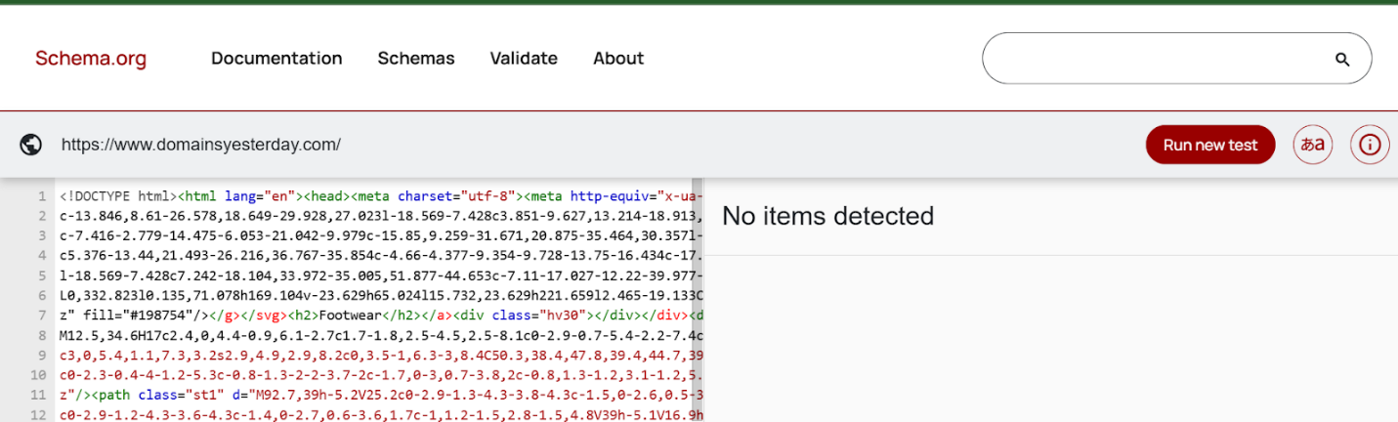

* **Blog Schema** is missing from the blog section. Implementing **Blog Schema** will help search engines understand the structure of blog content

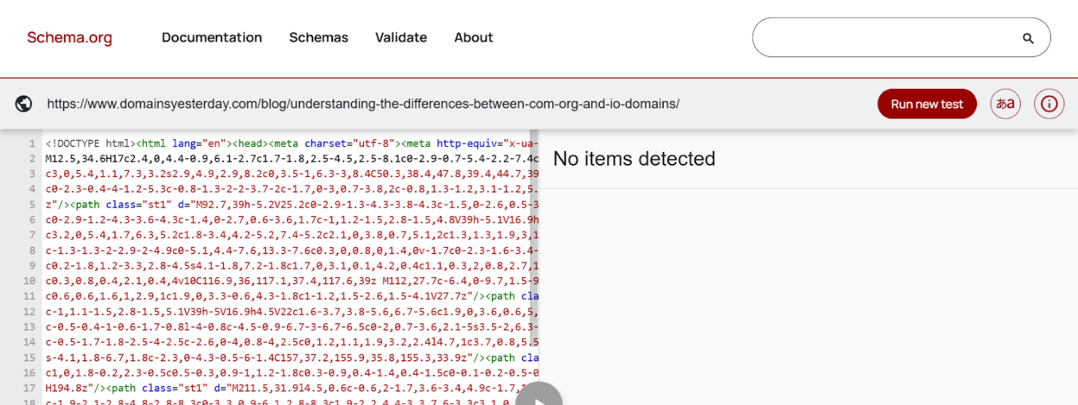

* Furthermore, the Domain Product Schema is not present. Since domains are being sold as products, adding **Product Schema** for domain listings is crucial to provide detailed information such as price, availability, and descriptions directly in search results.

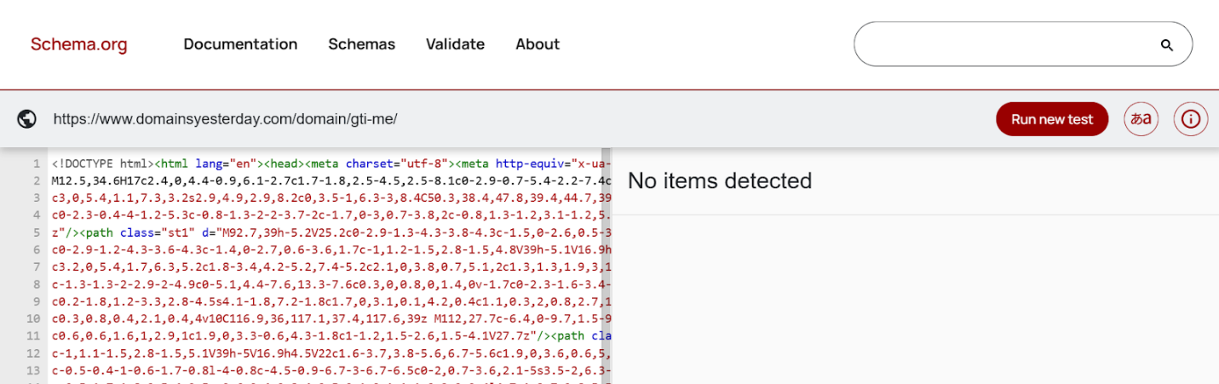

* Lastly, implementing **Breadcrumb Schema** across the website, especially in the blog and domain product sections, will improve navigation and enhance user experience and if possible made a separate faqs page and implement Faqs schema on that page

# **1.2 TECHNICAL SEO AUDIT**

## **SITE SPEED AND PERFORMANCE**

* The website's speed performance is good.

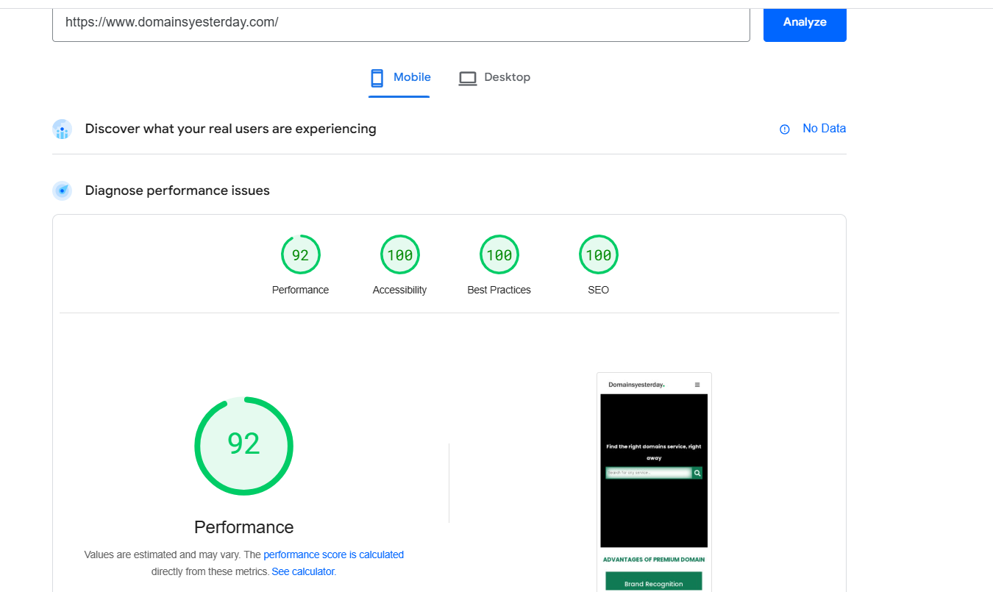

* 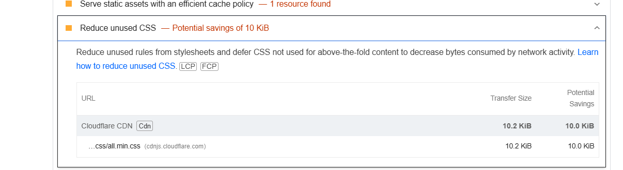However, there are some areas that need improvement, such as reducing unused CSS to optimize loading times and enhance overall efficiency.

## **MOBILE-FRIENDLINESS**

* In the mobile view, the contact section should be properly aligned to ensure a clean and organized layout. Additionally, icons for the address and phone number should be added to enhance readability and improve the user experience.

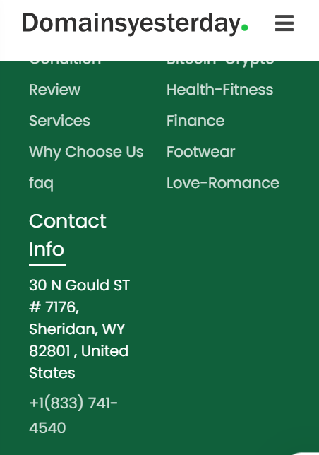

## **CANONICALIZATION & DUPLICATE CONTENT**

Multiple URLs on the website are canonicalized to a few specific URLs, particularly:

* 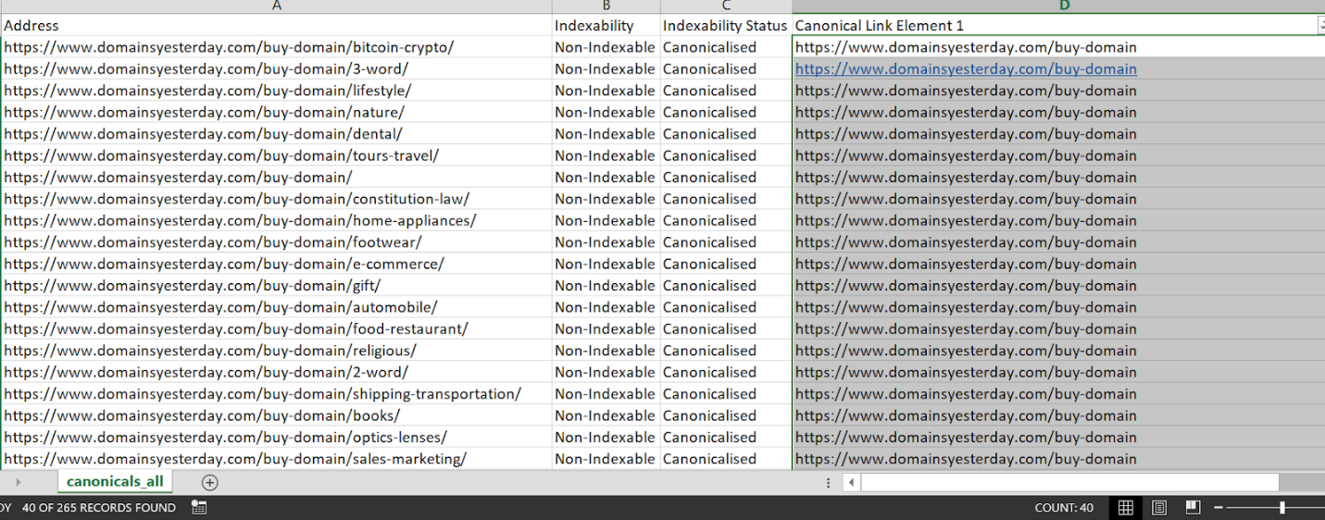40 URLs seem to have the canonical link pointing to https://www.domainsyesterday.com/buy-domain or similar generic URLs.

This indicates **incorrect or improper canonicalization** because:

**Duplicate Content Issue**: If multiple unique pages (like /buy-domain/nature/, /buy-domain/bitcoin-crypto/) have the same canonical tag, search engines will consider them as duplicates and may not rank them individually.

**Relevance Issue**: The canonical tag should point to the most relevant URL for each page to preserve their unique identity and keyword targeting.

**Recommendation**

Each page should have a unique canonical tag that points to itself, add a self referencing tag

Update the canonical logic in the CMS or website backend to ensure every page has its own correct canonical tag.

## **INDEXABILITY & CRAWLABILITY**

* The robots.txt file contains an incorrect sitemap URL. The current sitemap belongs to a different website and does not correspond to the correct domain. It needs to be updated with the appropriate sitemap URL for this website.

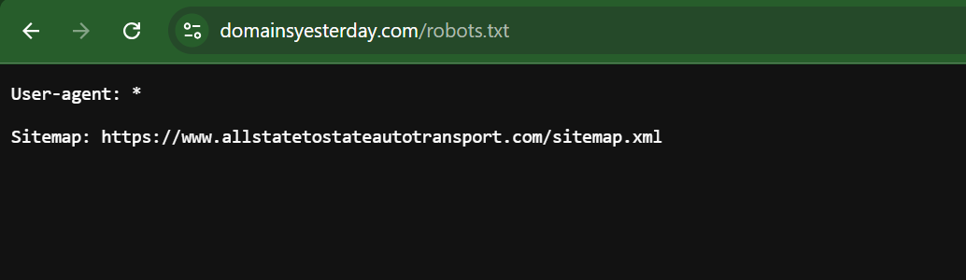

* This site does not have a sitemap.

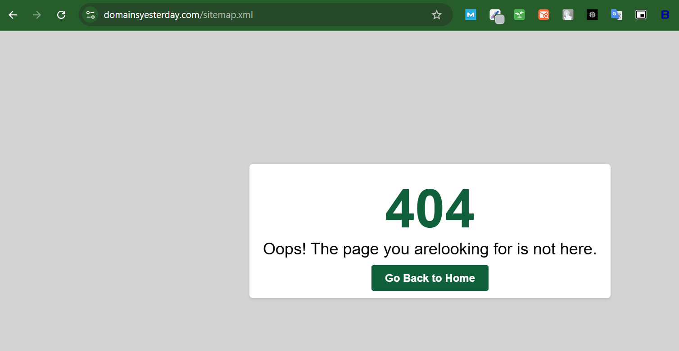

* The provided table lists orphan pages, which are web pages without any internal links pointing to them

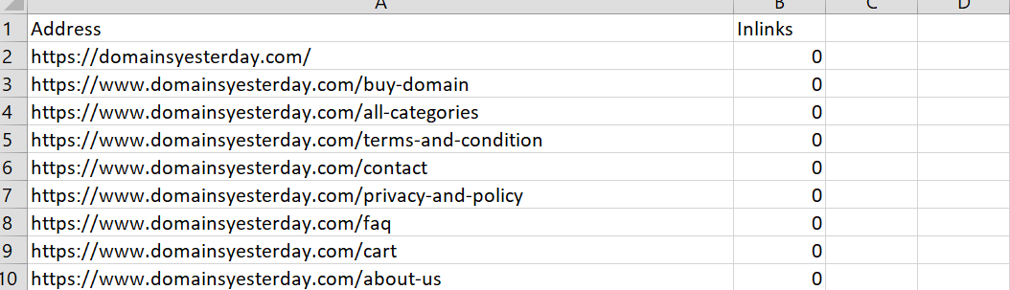

* The following URL is redirected to the same URL, which is not ideal. It should be removed to avoid unnecessary redirects.

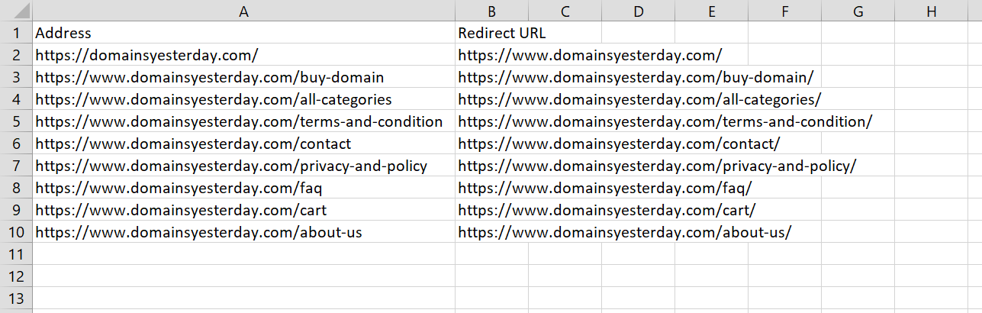

# **2.1 KEYWORD RESEARCH & STRATEGY**

## **HOME PAGE KEYWORDS**

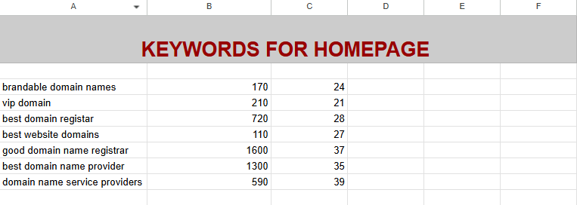

## **KEYWORDS FOR CLOTHING CATEGORY**

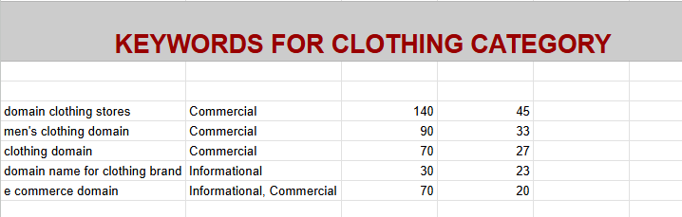

# **2.2 CATEGORY PAGE KEYWORDS**

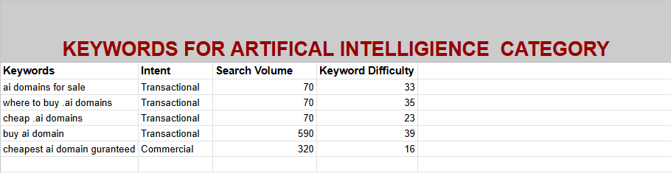

# **3.1 Competitor Analysis & SEO Strategy**

## **Keywords Competitor Analysis**

The current keyword analysis indicates that only 99 keywords are ranking for our brand, highlighting a significant opportunity to improve our search visibility. To enhance our SEO performance, we should strategically incorporate high-volume and relevant missing keywords into key pages of our competitor, such as the homepage and service pages.

**Recommendations:**

1. **Keyword Integration** – Optimize on-page content by naturally incorporating missing high-volume keywords to improve search rankings.
2. **Content Expansion** – Develop additional content, such as blog posts or FAQs, targeting these keywords to increase relevance.
3. **Competitor Benchmarking** – Analyze competitors' keyword strategies to identify gaps and opportunities for improvement.
4. **Internal Linking Strategy** – Use contextual linking to guide search engines and users toward high-priority pages.

By implementing these strategies, we can strengthen our keyword presence, improve organic visibility, and drive more targeted traffic to our website.

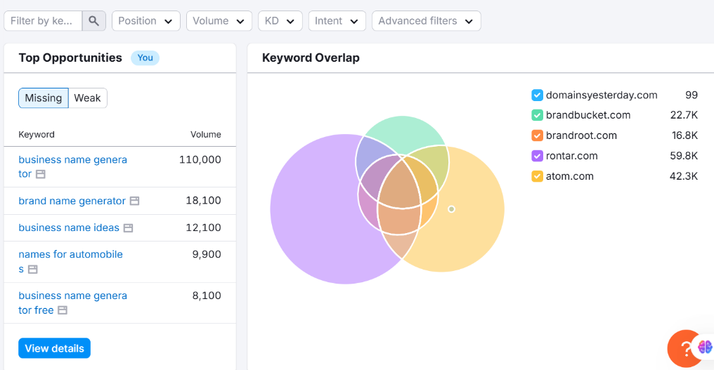

## **Competitor Backlinks Analysis**

Backlink analysis reveals that several high-authority links are missing compared to our competitors. For example, we have not yet created backlinks on platforms like Bing, and there are numerous listing sites where our presence is currently absent. To strengthen our website’s authority and improve search rankings, we should focus on acquiring backlinks from these missing sources.

**Recommendations:**

1. **Listing Sites & Directories** – Submit our website to reputable business directories and niche listing sites to build high-quality backlinks.
2. **Profile & Forum Links** – Create profiles on relevant platforms and engage in industry-related discussions to generate backlinks.

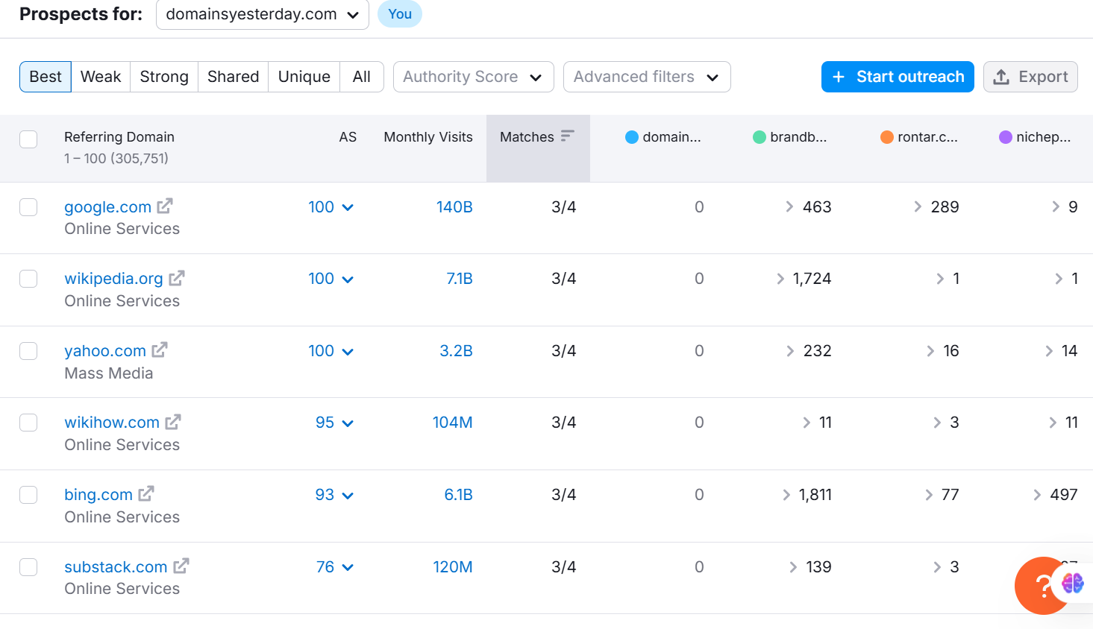

# **3.2 SEO STRATEGY**

## **Crawlability and Indexing Strategy**

* In the initial phase, we will focus on optimizing crawlability and indexing by implementing the correct technical SEO practices. This will help reduce the crawl budget, ensuring that search engine crawlers prioritize and efficiently discover our important pages. By minimizing unnecessary crawling of low-value or duplicate pages, we can improve the chances of having our key pages indexed and ranked effectively in search results.

## **Content optimization and internal linking**

* **Category Page Optimization**

Add relevant commercial keywords, such as "best beauty skincare domain," with low keyword difficulty. Add best relevant keywords that our our competitor is Using, Use semantic SEO approach in blog, service page and home page

Include well-written, informative content on category pages to provide context and improve search rankings. And make a content marketing funnel

Strengthen internal linking between category pages to build site authority and improve engagement.

* **Keyword Integration from Competitor Analysis**

Identify high-volume, relevant keywords that competitors are ranking for but are missing from the site.

Optimize key pages by naturally integrating these keywords.

Expand content by creating blog posts and FAQs targeting these keywords.

Develop an internal linking strategy to connect high-priority pages.

* **Mobile Usability Improvements**

Align the contact section properly to improve the layout on mobile devices.

Add icons for the address and phone number to enhance readability and user experience.

## **Long-Term SEO and Authority Building**

* **Competitor Backlink Strategy**

Identify high-authority backlinks that competitors have secured.

Submit the website to relevant business directories and niche listing sites to improve credibility.

Build profile and forum links by actively participating in industry-related discussions.

* **Content Expansion for Authority Building**

Develop pillar content and topic clusters based on high-value keywords.

Publish in-depth case studies, whitepapers, and comprehensive guides to establish expertise in the industry.

Create evergreen content that remains relevant over time and continues to attract traffic.

* **Site Performance and Speed Optimization**

Reduce unused CSS to improve page loading times.

Monitor Core Web Vitals and optimize elements based on insights from Google PageSpeed to Improve User Experience

## **Ongoing Monitoring and Continuous Improvement**

Conduct monthly SEO audits to track progress and identify new issues.

Perform quarterly competitor analysis to refine strategies and uncover new opportunities.

Continuously update and optimize content based on performance data.

Track key performance indicators using tools like Google Analytics, Google Search Console, and SEMrush.

This roadmap provides a structured approach to fixing immediate SEO issues, strengthening content and backlink strategies, and building long-term authority